CPAN-133 Operating System Assignment#2 Deadline:Oct 27, 2024

Wirte the Answer in your own words. The screenshot should contain command and output including your username.

Don’t copy & paste. Read about Humber’s academic dishonesty.

Your name: Krishna Rao Humber ID: N01687444

1. (8 points) Explain the permissions for following files:

(1.1) drwx 6 minhas staff 4096 Nov 18 2013 twelve

d (directory) rwx (read, write, execute)is the permission for the owner and the group.

6 is the number of hard links

Minhas is the name of the owner of the directory

Staff is the group name.

4096 is the size of the directory in bytes

Nov 18 is the last modification date.

Twelve is the name of the file.

(1.2) -rw 1 n012345 student 2495 Sep 10 2013 who.txt

-rw is the permission to read and write only for the owner.

1 is the number of hard links.

N012345 is the owner of the directory.

student is the group associated with the file.

2495 is the size of the file in bytes.

Sept 10 2013 is the last modification date for the file.

who.txt is the file name.

* 1. What type of files are these?
  2. drwx is the directory because t has d at the beginning and 1.2 -rw is a regular type of file as it has – at the beginning.
  3. Who is the owner?

For 1.1 the owner is minhas and for the second one owner is N012345

* 1. What are the group names?

For 1.1 the group name is staff and for the second one group name is student.

* 1. For each entry outline the permission granted to all type of users (owner, group, others)

For 1.1, rwx is the permission for the owner while the group and others only have no permission.

For 1.2, only the owner has rw permission while the group and others don’t have permission.

1. (4 points) For each of the following explain what permissions are granted. A file with
   1. 777 file1.txt

Here, owner,group and others have readwrite and execute permission.

* 1. 655 file2

Here,owner has read and write permission while grop and others have read and execute permission.

* 1. 664 file3

Here, owner and group has read and write permission while others have only read permission.

1. (1 point) . In the previous question which permission is the riskiest – why? Which of the above permission is safest – why?

777 is the riskiest permission because each owner group and others have read,write and execute permission. So anyone can delete or modify that file or can misuse it in any way.

664 is the safest permission because it only allows the owner and group to write on it. So in a way only trusted person have the access to modify the file. While others can only read the file and cannot perform any action.

1. (4 points) For the file -rw-wx-rwx foo.txt use symbolic representation change the permissions so that
   1. The Owner and the group do not have any permissions. Others can open it.
   2. The owner can write to it. The group can open it. Others will not have any permissions.
   3. Only group have permission to open it
   4. Only the owner can open it.

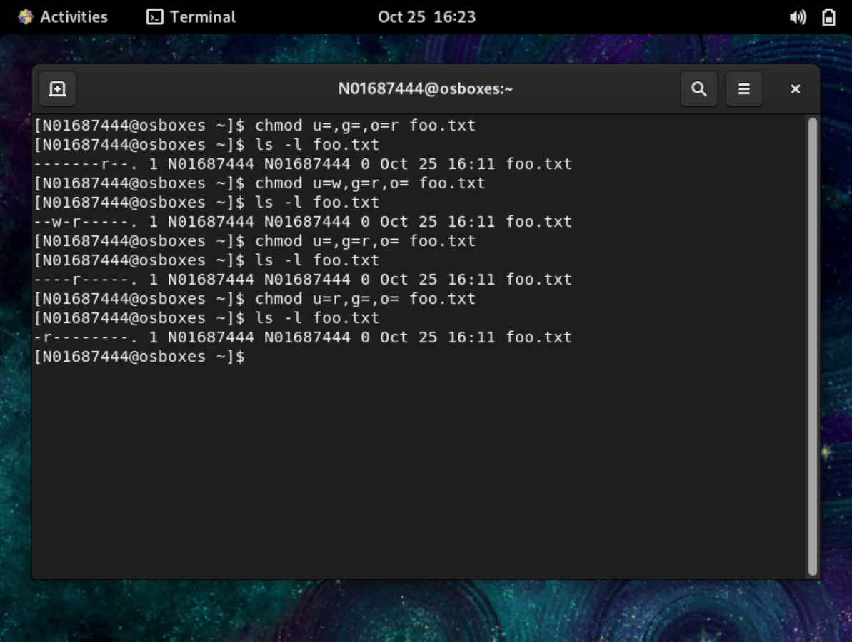

1. (8 points) vi/vim editor
   1. What are the 3 modes of vi? Explain the role of mode.

The 3 modes of vi/vim editor are command mode, insert mode and visual mode.

1. Command mode:- this is the default mode while opening a file.In this mode we can perform delete,copy, paste and other editing commands. One can access it by pressing esc key.
2. Insert mode:- In this mode we can enter or edit the text. We can access insert mode by pressing i,a,o.
3. Visual mode:- It is used to select and highlight the text. After selecting, one can cut,copy or change that text. One can access by pressing v or ctrl+v.
   1. How can you exit a file without exiting vi?

We can exite a file by first pressing escape and then typing :w.

* 1. How can you turn on line numbering in vi?

We can turn on line number by pressing :set number in command mode.

* 1. How is “copy and paste” and “cut and paste” performed in vi?

We can copy by using yy for the line and we can paste it by pressing p at desired location.

1. (10 points) File Manipulation

Create a directory under your home directory and name it *CPAN133-Assignment2*.

Create two sub-directories name them prof-info and student-info.

Access the directory named CPAN133-Assignment2. Create two empty files named professors.txt and students.txt

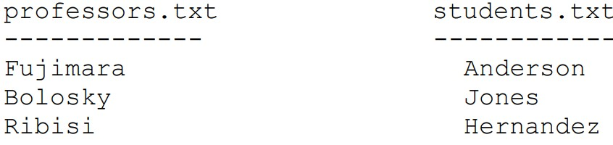

Figure 1: Professors and Students text

* 1. Use redirection operators and change the content of professors.txt and students.txt: see Figure 1 Did you use input redirection or output redirection? Explain.
  2. Use the paste command to combine professors.txt and students.txt sided by side and save it in a file named prof-stu.txt, see Figure 2

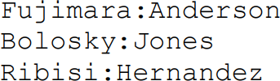

Figure 2: Paste Output

* 1. Sort prof-stu.txt in alphabetical order based on the professors’ name and store the result in a file named sorted-prof-stu.txt.
  2. Create a directory named academic-info and move sorted-prof-stu.txt under the academic-info di- rectory.

**Submission Guidelines**

Submit a pdf containing your answers to the questions on the submission link (Submission of Assign- ment1) under the Assignment Submission Folder on Blackboard.

Your document should contain your information: full name, student id and, section number.

Name the document as follows:

If your last name is Minhas and your name is Tahir, your assignment’s pdf file will be: MinhasTahirA2.pdf

LATE SUBMISSION will be penalized 5% per day up to 5 days

|  |  |  |  |  |  |  |  |
| --- | --- | --- | --- | --- | --- | --- | --- |
| Question: | 1 | 2 | 3 | 4 | 5 | 6 | Total |
| Points: | 8 | 4 | 1 | 4 | 8 | 10 | 35 |
| Bonus Points: | 0 | 0 | 0 | 0 | 0 | 0 | 0 |
| Score: |  |  |  |  |  |  |  |